Scrum Meeting #3

# Ashton Ford

*Acting scrum master and note taker*

Photo of repository, February 28, 2019.

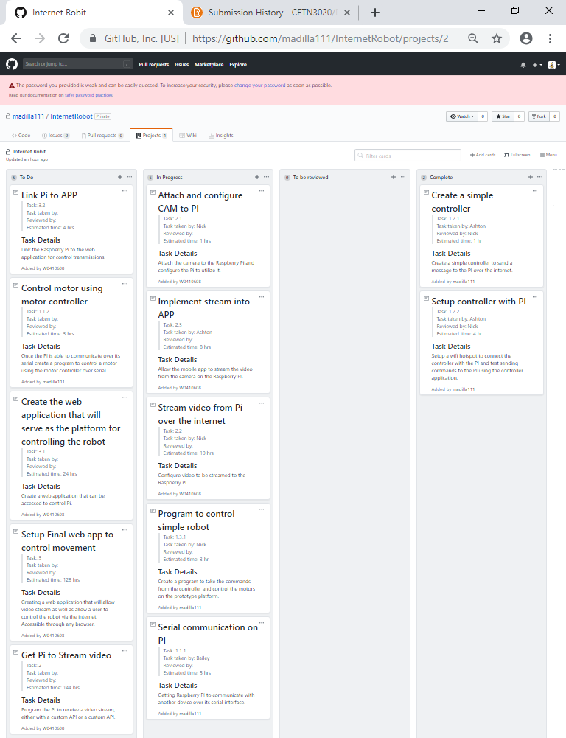

**New tasks:**

Stream video from Pi over the internet – Nick

Attach and configure CAM to Pi – Nick

Get Pi to stream video –

Implement stream into APP - Ashton

**What was accomplished since last meeting?**

Assigned new tasks.

**What is in-progress since last meeting?**

A couple more tasks have been added to the in-progress part of our repo. Nick has been assigned the tasks of Attaching and configuring the camera to the Pi and streaming video from the Pi to an internet browser. Ashton has been assigned the task of implementing the stream into the mobile app.

**Impediments & Resolutions**

* Serial still not working on the Raspberry Pi
* Parts not arriving